
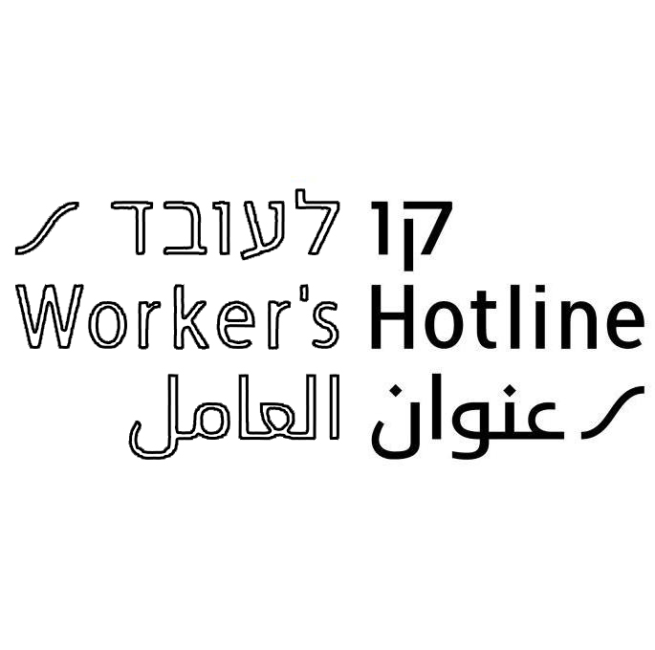
"Upholding Labor Rights in the Middle East"
KavLa'oved Migrant Labor Rights
A project funded by the European Union

Workers' Rights for Caregivers (10/2012)
Kav LaOved is a non-profit organization that provides consultation and legal aid to workers. The following rights are guaranteed by Israeli law to all workers in Israel whether Israeli or foreign (with or without a visa):
Minimum Wage | 4,300 NIS for a full-time job (186 hours per month); 172 NIS per day, 23.12 NIS per hour.
Payment Time | Your salary must be paid no later than the 9th of the month, for the previous month. Failure to pay on time will incur payment of compensation – 5% of the salary for the first week of delay and 10% of the salary and unpaid accumulated compensation for every following week of part of it. Every month of delayed payment 20% of the salary plus interest shall be paid.
Overtime | Work of more than 8 hours per day entitles to overtime payment. Payment: first two hours – an additional 25%; any hour after the first two hours – an additional 50%. Note: When the Labor Courts decide that a worker has in actual fact worked overtime, they have either based the payment on the extra hours he worked or they have made the employer pay an additional amount which ranges between 10-40% of the worker's salary.
Housing | Your employer must provide you with a bed and space in a wardrobe for your belongings.
Travel Expenses | Your employer has to give you a refund on your travel expenses, up to a maximum of 25.20 NIS per day.
Salary Deductions | If your employer pays you the minimum salary or more, he is entitled to deduct payments for Health Insurance, National Insurance and Housing, according to the regulations.
Weekly rest day | You should get 36 continuous hours off work per week, which includes a rest day according to your religion. If you worked on your rest day you should get 150% of the salary for 1.5 days (minimum – 387 NIS) and in addition a different rest day.
Annual Vacation | 12 days of paid vacation a year (not including the weekly rest day) for the first 4 years; 14 days for the fifth year; 16 days for the sixth year; 18 days for the seventh year. Payment: If you took your annual vacation, you will be entitled to your regular monthly salary. If you didn't take all or some of your vacation, you will be entitled to get paid for the value of each day. Calculation: minimum salary per day 172 NIS (or your actual salary per day – whichever is higher), multiplied by the number of days you are entitle to. You do not have to find a replacement or pay for it during your annual vacation!
Holidays | From the first day of work, you should get 9 paid religious holidays per year according to your religion, as long as the holidays don't fall on your weekly rest day. Payment: if you took a holiday you will be paid your regular wages. If you worked on a holiday you should be paid 150% of your daily salary (minimum 258 NIS), plus you should receive an alternative rest day.
Recuperation Pay | After one full year of work you should get 5 days recuperation pay (371 NIS per day); during the second and third year - 6 days; from the fourth until the tenth year - 7 days.
Sick pay | Your employer must pay your salary if you don't work because you are ill when you give him a doctor’s note. The first sick day is without pay; the second and third sick day - 50% of your daily salary; from the fourth sick day and onwards - 100% of your daily salary. The sick days are counted from the day you start working: 1 and 1/2 days for each month worked (18 days per yaer), up to a maximum of 90 sick days in total.
Severance/ separation pay | After one year of work you should be paid severance (Pitzuim) if you are fired or you finish your work because: your employer died or moved to a hospital or nursing home; your visa is not renewed; your work conditions get worse (e.g. non-payment of wages); you are ill; you give birth etc. Time of payment: at your last day of work. The severance pay is calculated according to one monthly minimum salary (4,300 NIS) or your salary including allowance – whichever is higher, multiplied by the number of years of work (including any part of a year's work). If you get part of your salary from an agency (Bituach Leumi), you are entitled to severance pay from your agency, for their part of your salary when you stop working with them. It is very important to demand the pay slip that the agency gives you. Failure to pay severance on time will incur compensation payments - 5% of the salary for the first week of delay and 10% of the salary and unpaid accumulated compensation for every following week of part of it. Every month of delayed payment 20% of the delayed compensation plus interest shall be paid.  An employer must provide housing to the caregiver for at least one week after the worker is fired (even if the employer gave the worker prior notice), or in case the employer passed away.
Notice  Prior to Resignation | A caregiver who works for more than 7 days MUST give prior notice in writing to both the agency (where he/she is registered) and to the employer. You are not allowed to leave the employer before the notice period is over. In the notice letter you must write that you plan to resign, the date you hand your employer the letter, and the last day of work. The notice period are: for work period between 7 days to 3 months – 7 days notice, from 3 to 6 months – 14 days, from 6 to 12 months – 21 days, over one year - one month notice. Always keep a copy of the notice letter to yourself. If you can, ask the employer and the agency to sign your copy to confirm they received the letter. If you fail to give the notice letter in time, you may loose your legal status and be deported!
Notice Prior to Firing / dismissal | Your employer must give you a written notice before firing you. The notice period depends on the period you worked. For the first 6 months - 1 day for each month; for the 7th month and up to a year - 6 days (1 day for each of the 6 months) + 2.5 days for each additional month; after 1 year- a month. Payment: In case the employer failed to give you notice, he must pay compensation amounting to the regular salary of the notice period you were entitled to.  Note: you are entitled to payment for notice period even if your employer dies.
Pension | A 2008 decree requires employers to set aside a pension fund for each worker. During 2008, employers were required to set aside 1.66% of the salary, of which 0.833% for severance pay. In 2009 3.32% needed to be set aside, 5% in 2010, 6.67% in 2011, 8.34% in 2012 and 10% in 2013. Based on Ministry of Industry, Trade and Labor instructions, employers of migrant workers must deposit the funds set aside in a bank account bearing the employee's name, and the sum must be given to the employee upon ending his tenure.
Rights for Part of a Year | You are entitled to receive your Annual Vacation and Holidays rights even if you have not worked for a full year (you will be entitled to a proportional number of days). For Severance Pay and Recuperation Pay, you are entitled to receive your rights also for part of a year's work, as long as you have worked for over one year.
Pregnancy and Maternity | It is illegal to fire a pregnant worker who has worked at least 6 months for the employer. When you give birth you should get coverage for your hospital stay as well as a one-time birth payment and 14 weeks of paid maternity leave from the National Insurance. It is important to go to the hospital with your passport and all pregnancy follow-up documents.
Health Insurance | Your employer must pay your health insurance for the entire employment period. If you stop working for your employer, it is recommended that you continue to pay for your health insurance with the same company so that you don't loose your benefits. If the employer cancels the medical insurance and you ask the insurance company within 30 days to continue to pay the insurance yourself, the insurance company must agree. In you change agency – make sure you stay with the same insurance company and that agency doesn't change it for you
National Insurance | Your employer must register you at the National Insurance Institute. It is important that you get a copy of the payment receipt with the National Insurance file number of your employer, which you will need if you stay in hospital (a work accident or giving birth).
Sexual Assault | Sexual assault and sexual harassment is illegal under Israeli law. This includes a threat to fire a worker if she refuses to have sex, indecent assault or offers of a sexual nature. Any worker who was harassed can contact Kav LaOved.
Agency fees | The agency is not allowed to charge any amount for arranging your working permit or bringing you to Israel. In addition, the agency is not allowed to charge you for finding an employer if you are already in Israel.
Getting organized before leaving | A worker, who finished his work in Israel and is in Israel for more than 63 months, may stay in Israel an additional period of 60 days after his visa expires.
Kav LaOved -Worker's Rights |  | 03-6883766 75 Nachalat Binyamin St, Tel Aviv  04-8643350, 18 Hertzl St, Haifa
Mesilla -Social problems, family and children |  | 03-6879727 3 Rishon LeTzion St., Tel Aviv
Physicians for Human Rights –health & medical insurance issues |  | 03-6873027/ 03-6873718, 9 Hadror St., Jaffa
Rape Crisis Center |  | Hotline for women – 1202, Hotline for men - 2103
Hotline for Migrant Workers -arrested workers |  | 03-5602530 75 Nachalat Binyamin St, Tel Aviv

